

**CAPSTONE PROJECT REPORT**

**Report 4 – Software Design Document**

– HoChiMinh, September 2020 –

**Table of Contents**

I. Project Report 4

1. Status Report 4

2. Team Involvements 4

3. Issues/Suggestions 4

II. Software Design Document 5

1. Overall Description 5

1.1 Assumptions 5

1.2 Design Constraints 5

2. System Architecture Design 5

2.1 Overall Architecture 5

2.2 System Architecture 6

2.3 Package Diagram 6

3. System Detailed Design 7

3.1 Feature: Photographer booking 7

*a.* *Class diagram* 7

*b.* *Activity diagram* 7

3.2 Feature: Photographer’s information management 7

*a.* *Class diagram* 7

*b.* *Sequence diagram (s)* 7

3.3 Feature: Account Management 7

*a.* *Class diagram* 7

*b.* *Sequence diagram (s)* 7

3.4 Account Management 7

*a.* *Class diagram* 7

*b.* *Sequence diagram (s)* 7

3. All 7

4. Class Specifications 8

4.1 XYZ Class 8

4.2 ABC Class 8

4.3 … 9

5. Data & Database Design 9

5.1 Database Design 9

5.2 Data File Design 13

# I. Project Report

## 1. Status Report

|  |  |  |  |
| --- | --- | --- | --- |
| **#** | **Work Item** | **Status** | **Notes (Work Item in Details)** |
| 1 |  | Pending |  |
| 2 |  | In Progress |  |
| 3 |  | Completed |  |

## 2. Team Involvements

|  |  |  |  |
| --- | --- | --- | --- |
| **#** | **Task** | **Member** | **Notes (Task Details, etc.)** |
| 1 |  | Thaott |  |
| 2 |  | Datbc |  |
| 3 |  | Kiendst |  |
| 4 |  | Mytn |  |

## 3. Issues/Suggestions

|  |  |  |  |
| --- | --- | --- | --- |
| **#** | **Issue** | **Status** | **Notes (Solution, Suggestion, etc.)** |
| 1 |  | Pending |  |
| 2 |  | In Progress |  |
| 3 |  | Completed |  |

# II. Software Design Document

## 1. Overall Description

### 1.1 Assumptions

Assuming all the users for this system have basic mobile knowledge and knows how to operate the system smoothly.

The process and algorithm for calculating available schedules are assumed to be given prior.

### 1.2 Design Constraints

Hard drive space: The system will need at least 8GB storage space and minimum 1GB Storage space in order to run the booking system.

## 2. System Architecture Design

### 2.1 Overall Architecture

***Figure 1 – Overall Architecture***

PBS system is consisting of there components, the spring boot web server provides APIs, two mobile applications for customers and photographers, and the web application for admin role.

We also use several third-party services such as Aws S3 for image storage, Firebase cloud messaging for push notification function and Amazon RDS for MySQL instance.

### 2.2 System Architecture

**2.2.1 Web server architecture**

We build our web server following n-tier architecture. We decided to use this pattern for following reasons:

* It has been proven to be a scalable architecture model.
* Provide reusability, maintainability and fault tolerance.
* Helps our members to create reusable and flexible functionality.

**2.2.2 Mobile app architecture**



### 

### 

***Figure 2 - Mobile App Architecture***

Bloc pattern allow us to separate our mobile app into 3 layers:

* Presentation: UI
* Business Logic Component: bloc (where we can manage events – click, tap, etc. - send a request to data layer, then retrieve data from data layer and response to input from UI through states).
* Data Layer: Repository (where we can retrieve data from sources).

### 2.3 Package Diagram

*[Provide the package diagram for each sub-system. The content of this section include the overall package diagram(s) and the explanation for each package. Please see the sample and description table format below]*

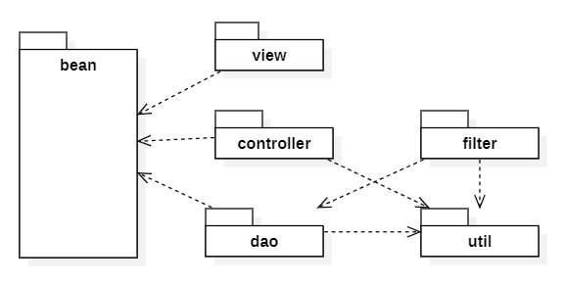

***Code Packages***

|  |  |  |
| --- | --- | --- |
| **No** | **Package** | **Description** |
| 01 | <Package name> | <Description of the package> |
| 02 |  |  |

## 3. System Detailed Design

### 3.1 Overall

### 3.1 Feature: Photographer booking

### *Class diagram*

### *Activity diagram*

### 3.2 Feature: Photographer’s information management

### *Class diagram*

### *Sequence diagram (s)*

### 3.3 Feature: Account Management

### *Class diagram*

### *Sequence diagram (s)*

### 3.4 Account Management

### *Class diagram*

### *Sequence diagram (s)*

### 3. All

#### a. Class Diagram

***Figure 2- Class diagram***

#### b. Sequence Diagram(s)

*[Provide the sequence diagram(s) for the feature, see the sample below]*

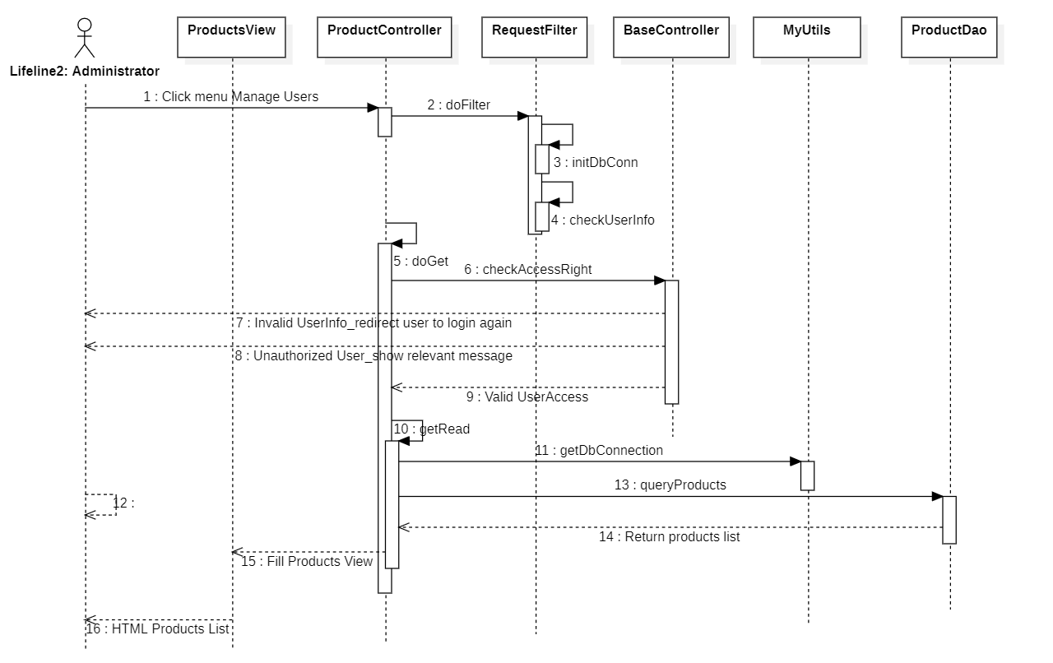

## 4. Class Specifications

### 4.1 XYZ Class

*[Provide the detailed description for the class methods]*

|  |  |  |
| --- | --- | --- |
| **No** | **Method** | **Description** |
| 01 | <method name> | <Description of the method, including the inputs, outputs & internal method processing> |
|  |  |  |

### 4.2 ABC Class

***Class Methods***

*[Provide the detailed description for the class methods]*

|  |  |  |
| --- | --- | --- |
| **No** | **Method** | **Description** |
| 01 | <method name> | <Description of the method, including the inputs, outputs & internal method processing> |
|  |  |  |

### 4.1 User

|  |  |  |  |
| --- | --- | --- | --- |
| **Attribute** | **Type** | **Visibility** | **Description** |
| id | Integer | private | Unique identifier of a user |
| username | String | private | The attribute represents username of a user |
| password | String | private | The attribute represents password of a user |
| fullname | String | private | The attribute represents full name of a user |
| avatar | String | private | The attribute represents avatar link of a user |
| phone | String | private | The attribute represents phone of a user |
| ratingCount | Float | private | The attribute represents the rating count of a user whose role is photographer |
| isBlocked | Boolean | private | The attribute represents if user has been blocked |
| createdAt | Date | private | The attribute represents created date of a user object |
| updatedAt | Date | private | The attribute represents updated date of a user object |

|  |  |  |  |  |
| --- | --- | --- | --- | --- |
| **No** | **Method** | **Visibility** | **Return Type** | **Description** |
| 1 | getter | public | Attribute Type | get attribute value |
| 2 | setter | public | void | set attribute value |

### 4.2 Role

|  |  |  |  |
| --- | --- | --- | --- |
| **Attribute** | **Type** | **Visibility** | **Description** |
| id | Integer | private | Unique identifier of a role |
| role | ERole | private | The attribute represents role name |

|  |  |  |  |  |
| --- | --- | --- | --- | --- |
| **No** | **Method** | **Visibility** | **Return Type** | **Description** |
| 1 | getter | public | Attribute Type | get attribute value |
| 2 | setter | public | void | set attribute value |

### 4.3 ERole

|  |  |  |  |
| --- | --- | --- | --- |
| **Attribute** | **Type** | **Visibility** | **Description** |
| ROLE_CUSTOMER |  |  | Enum attribute |
| ROLE_PHOTOGRAPHER |  |  | Enum attribute |
| ROLE_ADMIN |  |  | Enum attribute |

|  |  |  |  |  |
| --- | --- | --- | --- | --- |
| **No** | **Method** | **Visibility** | **Return Type** | **Description** |
| 1 | getter | public | Attribute Type | get attribute value |
| 2 | setter | public | void | set attribute value |

### 4.4 Package

|  |  |  |  |
| --- | --- | --- | --- |
| **Attribute** | **Type** | **Visibility** | **Description** |
| id | Integer | private | Unique identifier of a package |
| name | String | private | The attribute represents the package name |
| price | Integer | private | The attribute represents the package price |
| description | String | private | The attribute represents the package description |
| isAvailable | Boolean | private | The attribute represents if the package still available |
| createdAt | Date | private | The attribute represents created date of a package object |
| updatedAt | Date | private | The attribute represents updated date of a package object |

|  |  |  |  |  |
| --- | --- | --- | --- | --- |
| **No** | **Method** | **Visibility** | **Return Type** | **Description** |
| 1 | getter | public | Attribute Type | get attribute value |
| 2 | setter | public | void | set attribute value |

### 4.5 Service

|  |  |  |  |
| --- | --- | --- | --- |
| **Attribute** | **Type** | **Visibility** | **Description** |
| id | Integer | private | Unique identifier of a package |
| name | String | private | The attribute represents the name of a service |
| description | String | private | The attribute represents the service’s description |
| isActive | Boolean | private | The attribute represents if the service is still available |

|  |  |  |  |  |
| --- | --- | --- | --- | --- |
| **No** | **Method** | **Visibility** | **Return Type** | **Description** |
| 1 | getter | public | Attribute Type | get attribute value |
| 2 | setter | public | void | set attribute value |

### 4.6 Booking

|  |  |  |  |
| --- | --- | --- | --- |
| **Attribute** | **Type** | **Visibility** | **Description** |
| id | Integer | private | Unique identifier of a booking |
| bookingStatus | EBookingStatus | private | The attribute represents the status of a booking |
| startDate | Date | private | The attribute represents the starting date of a booking |
| endDate | Date | private | The attribute represents the ending date of a booking |
| serviceName | String | private | The attribute represents the service of a booking |
| price | Integer | private | The attribute represents the service price of a booking |
| customerCancelledReason | String | private | The attribute represents the reason if customer decided to cancel a booking |
| photographerCancelledReason | String | private | The attribute represents the reason if photographer decided to cancel a booking |
| rejectedReason | String | private | The attribute represents the reason if photographer decided to reject a booking |
| rating | Float | private | The attribute represents the rating of a booking |
| comment | String | private | The attribute represents the comment of a booking |

|  |  |  |  |  |
| --- | --- | --- | --- | --- |
| **No** | **Method** | **Visibility** | **Return Type** | **Description** |
| 1 | getter | public | Attribute Type | get attribute value |
| 2 | setter | public | void | set attribute value |

### 4.7 EBookingStatus

|  |  |  |  |
| --- | --- | --- | --- |
| **Attribute** | **Type** | **Visibility** | **Description** |
| Pending |  |  | Enum attribute |
| OnGoing |  |  | Enum attribute |
| Editing |  |  | Enum attribute |
| Rejected |  |  | Enum attribute |
| Cancelled |  |  | Enum attribute |
| Done |  |  | Enum attribute |

|  |  |  |  |  |
| --- | --- | --- | --- | --- |
| **No** | **Method** | **Visibility** | **Return Type** | **Description** |
| 1 | getter | public | Attribute Type | get attribute value |
| 2 | setter | public | void | set attribute value |

### 4.8 Album

|  |  |  |  |
| --- | --- | --- | --- |
| **Attribute** | **Type** | **Visibility** | **Description** |
| id | Integer | private | Unique identifier of album |
| name | String | private | The attribute represents the name album |
| thumbnail | String | private | The attribute represents the album’s thumbnail link |
| description | String | private | The attribute represents the album’s description |
| createdAt | Date | private | The attribute represents the created date of album object |
| isActive | Boolean | private | The attribute represents if album still active |
| likes | Integer | private | The attribute represents the album like count |

|  |  |  |  |  |
| --- | --- | --- | --- | --- |
| **No** | **Method** | **Visibility** | **Return Type** | **Description** |
| 1 | getter | public | Attribute Type | get attribute value |
| 2 | setter | public | void | set attribute value |

### 4.9 Image

|  |  |  |  |
| --- | --- | --- | --- |
| **Attribute** | **Type** | **Visibility** | **Description** |
| id | Integer | private | Unique identifier of image |
| description | String | private | The attribute represents the description of album |
| imageLink | String | private | The attribute represents the album’s image link |
| comment | String | private | The attribute represents the album’s comment |
| createdAt | Date | private | The attribute represents the created date of image object |

|  |  |  |  |  |
| --- | --- | --- | --- | --- |
| **No** | **Method** | **Visibility** | **Return Type** | **Description** |
| 1 | getter | public | Attribute Type | get attribute value |
| 2 | setter | public | void | set attribute value |

### 4.10 Category

|  |  |  |  |
| --- | --- | --- | --- |
| **Attribute** | **Type** | **Visibility** | **Description** |
| id | Integer | private | Unique identifier of category |
| category | String | private | The attribute represents the category name |
| iconLink | String | private | The attribute represents the category icon link |
| createdAt | Date | private | The attribute represents the created date of category object |
| updatedAt | Date | private | The attribute represents the updated date of category object |

|  |  |  |  |  |
| --- | --- | --- | --- | --- |
| **No** | **Method** | **Visibility** | **Return Type** | **Description** |
| 1 | getter | public | Attribute Type | get attribute value |
| 2 | setter | public | void | set attribute value |

### 4.11 Calendar

|  |  |  |  |
| --- | --- | --- | --- |
| **Attribute** | **Type** | **Visibility** | **Description** |
| id | Integer | private | Unique identifier of category |
| startHour | Date | private | The attribute represents the start hour of photographer’s working time |
| endHour | Date | private | The attribute represents the end hour of photographer’s working time |
| repetitionType | Integer | private | The attribute represents the repetition type of a calendar |

|  |  |  |  |  |
| --- | --- | --- | --- | --- |
| **No** | **Method** | **Visibility** | **Return Type** | **Description** |
| 1 | getter | public | Attribute Type | get attribute value |
| 2 | setter | public | void | set attribute value |

### 4.12 Address

|  |  |  |  |
| --- | --- | --- | --- |
| **Attribute** | **Type** | **Visibility** | **Description** |
| id | Integer | private | Unique identifier of address |
| addressName | String | private | The attribute represents the address name |
| longitude | String | private | The attribute represents the longitude of a location |
| latitude | String | private | The attribute represents the latitude of a location |
| street | String | private | The attribute represents the street of a location |
| district | String | private | The attribute represents the district of a location |
| province | String | private | The attribute represents the province of a location |
| city | String | private | The attribute represents the city of a location |
| createdAt | Date | private | The attribute represents the created date of an address object |
| updatedAt | Date | private | The attribute represents the updated date of an address object |

|  |  |  |  |  |
| --- | --- | --- | --- | --- |
| **No** | **Method** | **Visibility** | **Return Type** | **Description** |
| 1 | getter | public | Attribute Type | get attribute value |
| 2 | setter | public | void | set attribute value |

## 5. Data & Database Design

### 5.1 Database Design

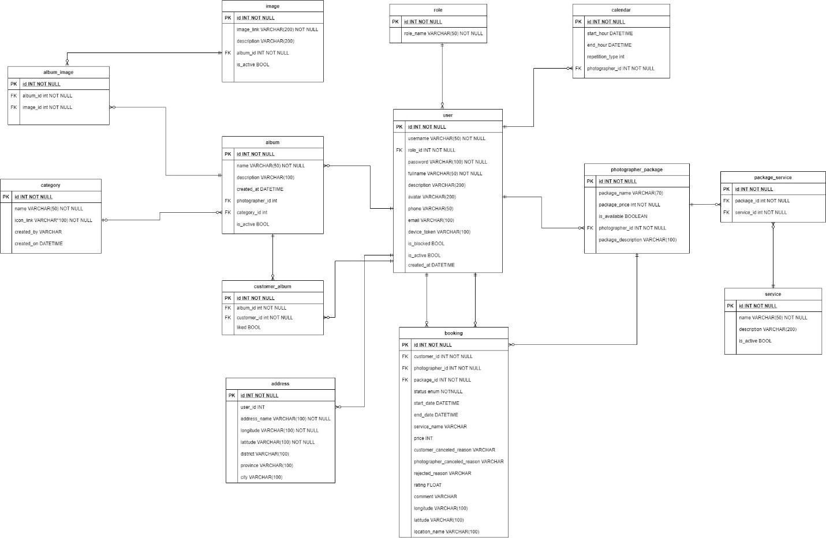

***Figure 3 – Database design***

#### User

|  |  |  |  |  |  |  |  |
| --- | --- | --- | --- | --- | --- | --- | --- |
| **#** | **Field name** | **Type** | **Size** | **Unique** | **Not Null** | **PK/FK** | **Notes** |
| 1 | id | int |  | X | X | X |  |
| 2 | username | varchar | 50 | X | X |  |  |
| 3 | password | varchar | 100 |  | X |  |  |
| 4 | fullname | varchar | 50 |  | X |  |  |
| 5 | description | varchar | 200 |  |  |  |  |
| 6 | avatar | varchar | 200 |  |  |  | Avatar image link of user |
| 7 | phone | varchar | 50 |  |  |  |  |
| 8 | email | varchar | 100 |  |  |  |  |
| 9 | device_token | varchar | 100 |  |  |  | The firebase token of device, using for firebase messaging. |
| 9 | is_blocked | boolean |  |  |  |  |  |
| 10 | is_active | boolean |  |  |  |  |  |
| 11 | created_at | datetime |  |  |  |  |  |
| 12 | role_id | int |  |  | X | X |  |

#### Role

|  |  |  |  |  |  |  |  |
| --- | --- | --- | --- | --- | --- | --- | --- |
| **#** | **Field name** | **Type** | **Size** | **Unique** | **Not Null** | **PK/FK** | **Notes** |
| 1 | id | int |  | X | X | X |  |
| 2 | role_name | varchar | 50 |  | X |  |  |

#### Photographer-Package

|  |  |  |  |  |  |  |  |
| --- | --- | --- | --- | --- | --- | --- | --- |
| **#** | **Field name** | **Type** | **Size** | **Unique** | **Not Null** | **PK/FK** | **Notes** |
| 1 | id | int |  | X | X | X |  |
| 2 | package_name | varchar | 70 |  | X |  |  |
| 3 | package_price | int |  |  | X |  |  |
| 4 | is_available | boolean |  |  |  |  |  |
| 5 | package _description | varchar | 100 |  |  |  |  |
| 6 | photographer _id | int |  |  | X | X |  |

#### Package-Service

|  |  |  |  |  |  |  |  |
| --- | --- | --- | --- | --- | --- | --- | --- |
| **#** | **Field name** | **Type** | **Size** | **Unique** | **Not Null** | **PK/FK** | **Notes** |
| 1 | id | int |  | X | X | X |  |
| 2 | package_id | int |  |  | X | X |  |
| 3 | service_id | int |  |  | X | X |  |

#### Service

|  |  |  |  |  |  |  |  |
| --- | --- | --- | --- | --- | --- | --- | --- |
| **#** | **Field name** | **Type** | **Size** | **Unique** | **Not Null** | **PK/FK** | **Notes** |
| 1 | id | int |  | X | X | X |  |
| 2 | name | varchar | 50 |  | X |  |  |
| 3 | description | varchar | 200 |  |  |  |  |
| 4 | is_active | boolean |  |  |  |  |  |

#### Booking

|  |  |  |  |  |  |  |  |
| --- | --- | --- | --- | --- | --- | --- | --- |
| **#** | **Field name** | **Type** | **Size** | **Unique** | **Not Null** | **PK/FK** | **Notes** |
| 1 | id | int |  | X | X | X |  |
| 2 | status | enum |  |  | X |  | There will be 6 status: Pending, Ongoing, Editing, Done, Rejected, Canceled |
| 3 | start_date | datetime |  |  | X |  |  |
| 4 | end_date | datetime |  |  | X |  |  |
| 5 | service_name | varchar | 100 |  | X |  | Package’s name |
| 6 | price | int |  |  | X |  | Package’s price |
| 7 | customer  _canceled  _reason | varchar | 100 |  |  |  | In case customers cancel and provide their reason |
| 8 | photographer _canceled _reason | varchar | 100 |  |  |  | In case photographers cancel and provide their reason |
| 9 | rejected_reason | varchar | 100 |  |  |  | In case photographers reject the request and provide reason |
| 10 | rating | float |  |  |  |  | After booking is done, customer can rate the booking |
| 11 | comment | varchar | 100 |  |  |  | After booking is done, customer can comment on the booking |
| 12 | longitude | varchar | 100 |  |  |  |  |
| 13 | latitude | varchar | 100 |  |  |  |  |
| 14 | location_name | varchar | 100 |  |  |  | The shooting location picked by customer |
| 15 | customer_id | int |  |  | X | X |  |
| 16 | photographer _id | int |  |  | X | X |  |
| 17 | package_id | int |  |  | X | X |  |

#### Album

|  |  |  |  |  |  |  |  |
| --- | --- | --- | --- | --- | --- | --- | --- |
| **#** | **Field name** | **Type** | **Size** | **Unique** | **Not Null** | **PK/FK** | **Notes** |
| 1 | id | int |  | X | X | X |  |
| 2 | name | varchar | 50 |  | X |  |  |
| 3 | description | varchar | 100 |  |  |  |  |
| 4 | created_at | datetime |  |  |  |  |  |
| 5 | is_active | boolean |  |  |  |  |  |
| 6 | photographer _id | int |  |  | X | X |  |
| 7 | category_id | int |  |  |  | X |  |

#### Address

|  |  |  |  |  |  |  |  |
| --- | --- | --- | --- | --- | --- | --- | --- |
| **#** | **Field name** | **Type** | **Size** | **Unique** | **Not Null** | **PK/FK** | **Notes** |
| 1 | id | int |  | X | X | X |  |
| 2 | address_name | varchar | 100 |  | X |  |  |
| 3 | longitude | varchar | 100 |  | X |  |  |
| 4 | latitude | varchar | 100 |  | X |  |  |
| 5 | district | varchar | 100 |  |  |  |  |
| 6 | province | varchar | 100 |  |  |  |  |
| 7 | city | varchar | 100 |  |  |  |  |
| 8 | user_id | int |  |  | X | X |  |

#### Category

|  |  |  |  |  |  |  |  |
| --- | --- | --- | --- | --- | --- | --- | --- |
| **#** | **Field name** | **Type** | **Size** | **Unique** | **Not Null** | **PK/FK** | **Notes** |
| 1 | id | int |  | X | X | X |  |
| 2 | name | varchar | 50 |  | X |  |  |
| 3 | icon_link | varchar | 100 |  | X |  | Link for the icon of category |
| 4 | created_by | varchar | 100 |  |  |  | Name of the admin who created the category |
| 5 | created_at | datetime |  |  |  |  |  |

#### Album-Image

|  |  |  |  |  |  |  |  |
| --- | --- | --- | --- | --- | --- | --- | --- |
| **#** | **Field name** | **Type** | **Size** | **Unique** | **Not Null** | **PK/FK** | **Notes** |
| 1 | id | int |  | X | X | X |  |
| 2 | album_id | int |  |  | X | X |  |
| 3 | image_id | int |  |  | X | X |  |

#### Image

|  |  |  |  |  |  |  |  |
| --- | --- | --- | --- | --- | --- | --- | --- |
| **#** | **Field name** | **Type** | **Size** | **Unique** | **Not Null** | **PK/FK** | **Notes** |
| 1 | id | int |  | X | X | X |  |
| 2 | image_link | varchar | 200 |  | X |  |  |
| 3 | description | varchar | 200 |  |  |  |  |
| 4 | is_active | boolean |  |  |  |  |  |
| 5 | album_id | int |  |  | X | X |  |

#### Customer-Album

|  |  |  |  |  |  |  |  |
| --- | --- | --- | --- | --- | --- | --- | --- |
| **#** | **Field name** | **Type** | **Size** | **Unique** | **Not Null** | **PK/FK** | **Notes** |
| 1 | id | int |  | X | X | X |  |
| 2 | liked | boolean |  |  |  |  | represent if customer has liked the album |
| 3 | album_id | int |  |  | X | X |  |
| 4 | customer_id | int |  |  | X | X |  |

#### Calendar

|  |  |  |  |  |  |  |  |
| --- | --- | --- | --- | --- | --- | --- | --- |
| **#** | **Field name** | **Type** | **Size** | **Unique** | **Not Null** | **PK/FK** | **Notes** |
| 1 | id | int |  | X | X | X |  |
| 2 | start_hour | datetime |  |  |  |  |  |
| 3 | end_hour | datetime |  |  |  |  |  |
| 4 | repetition_type | enum |  |  |  |  |  |
| 5 | photographer _id | int |  |  | X | X |  |

### 5.2 Data File Design

We use Aws S3 to store files and images.

|  |  |  |  |
| --- | --- | --- | --- |
| **#** | **File Name** | **Type** | **Notes** |
| 1 | User avatar | Image | path: “/{userId}/{userId}-avatar” |
| 2 | Photographer album thumbnail | Image | path: “/{ptgId}/{ptgId}/{albumid}/{albumId}-thumbnail” |
| 3 | Photographer album image | Image | path: “/{ptgId}/{ptgId}/{albumid}/{albumId}/{imageId}-image” |
| 4 | Photographer cover image | Image | path: “/{ptgId}/{ptgId}-cover” |
| 5 | Category icon image | Image | path: “/categories/{categoryId}-category” |